**Evalue-2: Qn 2:**

**Function Anatomy:**

Eg:

Function update(a,b,c)

{

Return a+b+c;

}

Here function keyword is indicates it is a function and it is followed by a function name update, a,b,c are the parameters passed to the function. It returns the sum of a+b+c when it is called.

The return keyword is optional.

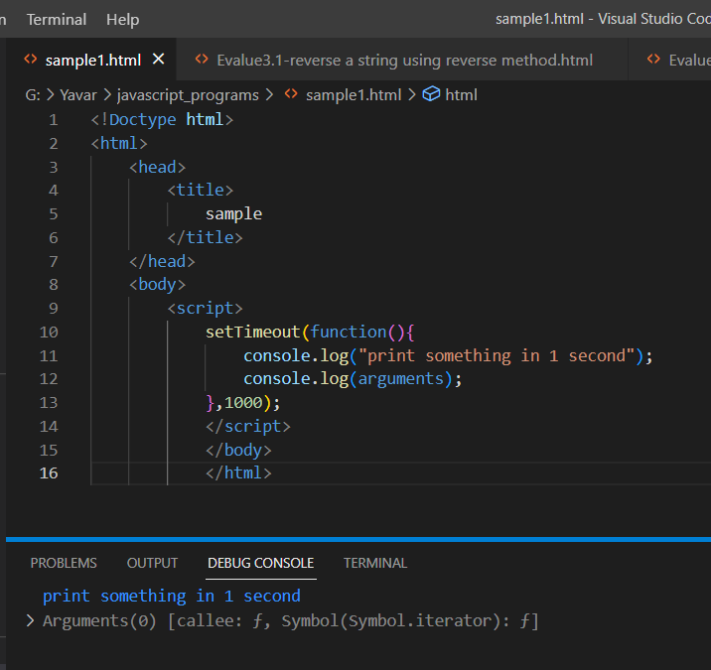

**Anonymous functions:**

A function without any names are called anonymous functions and it takes the same syntax.

**Assigning Functions to variables:**

Anonymous functions can be assigned to a variable making them named functions again.

